Lab Exercise 1- Docker Fundamental Commands
Name:Dimple Lulla
Sap id: 500120422
Roll no.: R2142231447
Objective
Learn and practice the fundamental Docker CLI commands to:
- Manage images and containers
- Understand container lifecycle
- Build and run applications using Docker

1. Setup
Prerequisites
- Docker installed on your system
(Check using: docker --version)
- Internet access to pull images

2. Basic Docker Commands
Step 1: Verify Installation
docker --version
docker info
Expected Output: Docker version and system details.
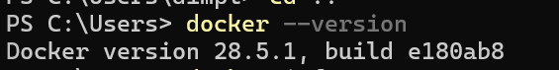
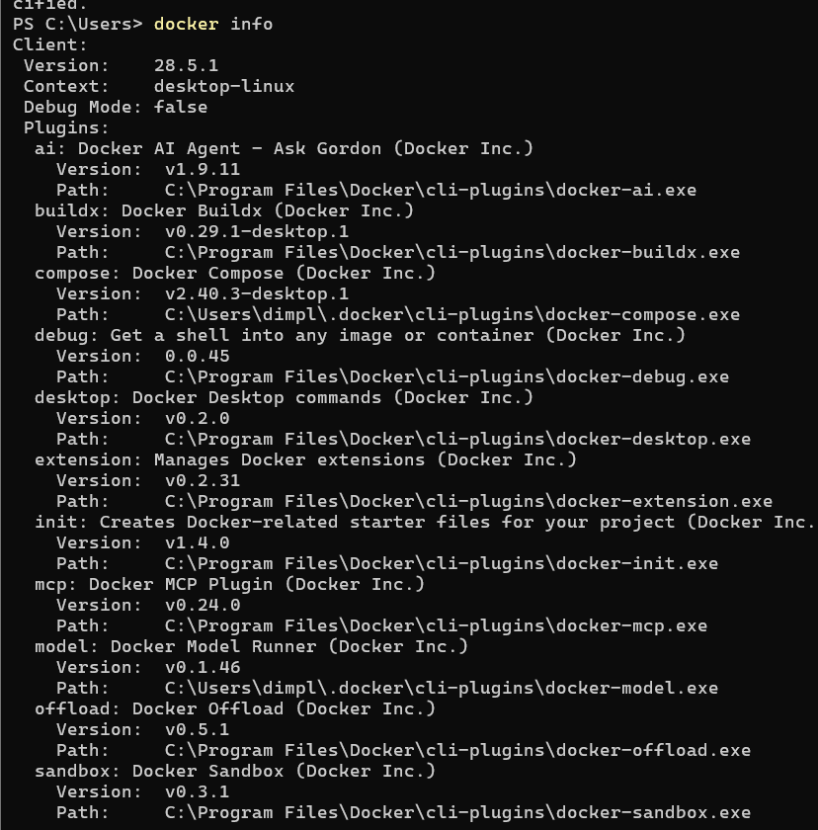

Step 2: Pull an Image from Docker Hub
docker pull ubuntu:latest
Explanation: Downloads the latest Ubuntu image from Docker Hub.
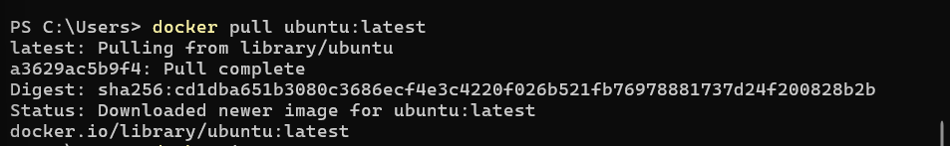
Check available images:
docker images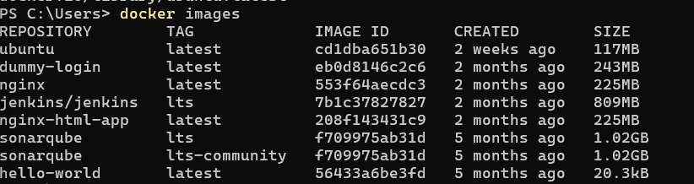

Step 3: Run a Container
Run Ubuntu interactively:
docker run -it --name myubuntu ubuntu bash

Now you’re inside a running container (prompt will change).
Exit:
exit

Step 4: List Containers
- Show running containers:
docker ps
- Show all containers (including stopped):
docker ps -a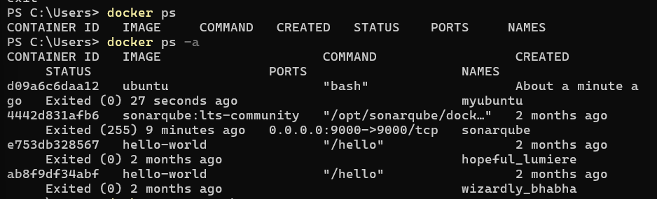

Step 5: Start / Stop / Remove Containers
# Start a stopped container
docker start <container_id>
# Stop a running container
docker stop <container_id>
# Remove a container
docker rm <container_id>
Tip: Use docker ps -a to get container IDs. 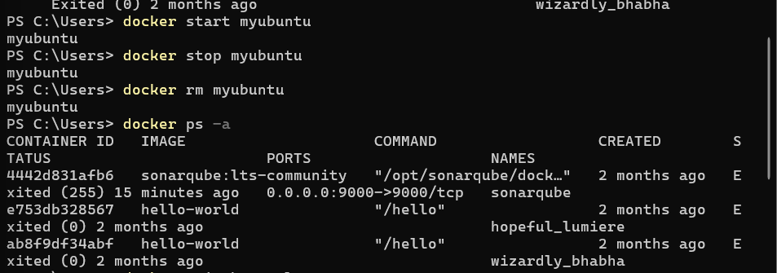

Step 6: Remove Images
docker rmi ubuntu:latest
Note: You must stop and remove all containers using that image first. 